alexander.dmytriiev@servicenow.com

October 5

Transcript:
Them: You can assess yourself, your organization, in different dimensions. That would be how ready you are to intake AI instruments like the European Act on AI. How prepared you are against a competitor in a particular area. Module number 2, we call it the Regulations Navigator. So AI instruments are becoming very tricky.
Me: Uh. Okay.
Them: For example, if you take a look at the United States, right? There are different levels of legislation. So there are executive orders.
Me: So there are 2 orders. Based on delivering AI at 900 a gallon.
Them: Based on, related to AI that apply at the federal level. There are, you know, adoptions of the European Act on AI in general by many companies. And if you are in specific states like Colorado and New York, There is legislation that those states came up with to regulate AI. When you deploy an AI system in a particular region, you have to think, what is all the applicable legislation that applies to me that I have to comply with? And that's why we have this Regulations Navigator software. You enter the geographic region where exactly your AI system is going to be deployed, and it allows you to navigate, okay, this is all the legislation that applies to you that you should comply with, and you can take a look at it and so on.
Me: And. So when you look at, for example, are you a region that has to place all the legislation that applies to you that I have to advise on? And that's why we are building this application software. I. And it doesn't help us to build up, so this is
Them: And legislation always changes very often, so this keeps up to date. We talked about the system catalog, so we also offer a system catalog where you can enter all the metadata we talked about on an AI system. And by the way, you know, we not only offer the software, but more importantly, right, we offer services. So if a client comes and tells us, you know what, I don't know how many AI systems I have in production, we'll set up a team of people with the right software to go into your organization. You know, we run software to discover what AI systems are there. We make an inventory, we curate it, we give it to you back. There is something called inventory scan. So there is a lot of times where something is running, you don't even know where, right? There is data that you don't even know who is the owner. So we have software in partnership with other vendors that can actually— you provide the network access, basically scans the network, scans all the databases, all the storage. Comes back with a list of, okay, this is all what I found, right? And these are potential owners. And then you can go back and start stitching together the system catalog.
Me: Something is happening. Yeah.
Them: We have the Risk Companion. This is, you can think of it, remember that we said that it was very important to know the risk level of your AI system, and that level of risk depends on what legislation you're using. So we have a chatbot that If you tell it, you know what, I want to comply with the European Act on AI and NIST, it'll ask you several questions, less than 30, to come up with, you know, your system is high Medium or low level.
Me: This. High medium.
Them: And similarly, we not only offer the software, but we also offer services to say, you know what, you want to know the level of risk for all your organization, we're gonna organize that for you. We'll come back with the risk level.
Me: And.
Them: Finally, this is my last slide. What we have is a module that allows you to create custom assessments. You remember that Some corporations like finance, healthcare, you know, the hardware industry, chip, telco industry, they have specific requirements. So we have a software that allows you to put together a questionnaire and then select the scoring system. That you can apply to any person going through the approval process to put an AI system into production and then record that information, be able to contact them in real time and so on. We have a module to perform red teaming. In fact, we have been doing red teaming for
Me: And.
Them: A lot of our clients that are basically generating frontier models, they come to Accenture and say, hey, I want to make sure that my model is the best in the market. Can you run it against X, Y, and Z? And we will use this software to basically use AI to generate automatic prompts based on a list of topics of interest for a particular frontier model. We go back, thousands of test cases. We come back to our client with a report saying, you know what, this is how your frontier model compares to this other one, and these are the vulnerabilities that we identified. For example, your model actually, you know, has issues with consumption on children's underage X, you know, something like that.
Me: Uh. Okay. Thank.
Them: We have a module for continuous monitoring, and you can imagine it does what you guys are doing here. So you can specify these are all the metrics and controls that I need to comply with, how often I need to sample. And it'll basically generate alerts, send it to people, and then also it'll generate automatically a ticket.
Me: Okay. Uh, it's in here.
Them: We have integration with different ticketing systems so that you can keep track of all the AI incidents and then go back and then fix it and then come back and put it into production. And finally, control management. We again talked extensively on it, but basically we have software that allows you to say, you know what, these tests that I'm running map to this control.
Me: Yeah. Yep. My this.
Them: And this control can be run automatically and so on. So hopefully you got a quick glimpse on the full end-to-end process of creating a trustworthy AI system, and you also got to understand, you know, some of the offerings that we have. At a high level, I think what's different from Accenture to other vendors is that we not only give you the software, we do things for you, right? We offer services. So thank you so much for your attention.
Me: Yep. We. So
Them: Perfect. Thank you. very much for that, Emmanuel. That is the end of the lightning talk. Just as a reminder for everyone, we spoke about the start and Guy spoke about it. We are working closely with Accenture on launching the Trustworthy AI Governance Project. More information will be shared on that in the sessions at Innovate later this week. But if you do have any questions for Emmanuel, please do go and speak with him. He'll be here all day. And with the work you're doing today, we'll directly be contributing. That will be taking the solutions and using them to help us build this program with Accenture as part of TM Forum. And if you are interested in Joining us on that journey and coming and getting involved, please come and speak with me as well. I'll be more than happy to do that. With that being said, it's back over to you. Continue the work you're doing. The next lightning talk will be at 1 o'clock. We'll also have some lunch served just before then. Any questions, please reach out to us again. We've got the technical support in the room to help you with that. So best of luck everyone and enjoy your morning hacking. Oh, sorry, Abhishek.
Me: Exactly their just. It's related with something connection. Yeah, yeah, that, that is that question. Okay, sure, sir.
Them: AWS in terms of ServiceNow connection. So
Me: So yeah, uh, so the— okay.
Them: So, uh, hello all. Uh, just a quick thing. Um, we heard from a number of people that, uh, you're facing difficulty in integrating to ServiceNow and also the 2 files that were missing from Maverick Digital Twin, they have been uploaded. But I'll let, uh, they, we have, uh, significantly simplified the ServiceNow integration. Vivek will give a quick, uh, update on it.
Me: We.
Them: Um, yeah, so I'm not sure if— I think Milind posted the steps in the Teams chat this morning, so, uh, so are people able to log into ServiceNow. I was walking around. I know a couple of teams were able to connect successfully, but if people are having issues, then please let us know. But the procedure is pretty straightforward. You just have to pull in the AWS. So there is a user created for you. So like the difference between your lab from yesterday and this morning is there is a new ServiceNow user created in your environment. So you should be able to pull the secret or the access key and the secret access key stored in an AWS service called Secrets Manager. Milind provided the steps this morning to pull that information. Once you— and if I'm not wrong, like the steps you sent actually pulls all the information you need to do the integration with ServiceNow. So you can just ignore any instructions we have on that module, Module 11. You can just use those simple steps. 125 and what output is expected is also there and from what steps and that's what you need to go into that ServiceNow AICT.
Me: Okay. No. Okay. Yeah in the chart. So well. Yeah.
Them: Feed that in and your connections would be up. The reason we— I say that with some confidence is there are 9 teams in the morning which Alex validated has already logged in and they can see it on their end. So This should be working, but still, as I said, if there's something which is amiss, we can all reach out to any one of us. We can, we can help you with that. So that's on the service now on, I think, we can also add any questions on ServiceNow before I move to the next one.
Me: Because I
Them: Yeah, okay, we can quickly showcase as well how this would look.
Me: We.
Them: And then, uh, what, uh, Alex will be here today, or Okay, so we will have some representation from ServiceNow as well, and he's pretty active on the Teams chat. So if you have ServiceNow-specific questions, we request to reach out to him and his team because there are As I said, we only worked on the integration aspect of it. And then one more thing about this integration, right? So this is your WhatsApp account. This is your— like, each team has got an account number, your own isolated like a virtual space, right, where you're doing all the work, your environment is there. What they are doing is they have provided one common for all the teams. So we just need to be— make those kind of distinctions and you have the login. That's the reason why if you see in the instruction, we have requested that if you are creating any resources, do have a team ID on it so that you can distinguish what is yours from other teams in ServiceNow.
Me: Should. You. So this is your mother. Yeah. Yes, so, uh, one of my teammates, he mentioned like one query in the chat, so he's facing this feature related. Okay, so would you be willing to share a screen so everyone can also see while we walk through what we are doing?
Them: That's one thing. Another thing is we are— this integration is polling or pulling What resources and the logs are on your AWS environment. So that's how this integration works. It's one way they just do get list, these kind of AWS API calls to build the visibility they have built on their side. So to be very clear, yeah.
Me: Okay. Hello? Hi, uh, hi, uh, can you share your screen on the, like, uh, I mean Teams? Uh, like one more time, sorry.
Them: Yeah, and then what we'll do is I think we are getting a team to share. On the Teams chat, and we can do a live troubleshooting with them.
Me: Uh, private room. Yep, there's a possibility to join the private room. We can join that. No, no, no, no, no, no. We can share the screen. Hey, hi, hello. This is Vivek with AWS. I'm one of the facilitators here. So if you're okay to share your screen in the main Teams channel, We can guide you through how you need to go through configuring ServiceNow so that way other people can also benefit from that. Are you okay to do that? That should be fine. I'm good with that. Yeah, yeah. We can do that should I do it in the main Teams channel? Yeah, yeah. And if you want, we can actually chat in the Teams meeting itself so everyone can hear what we're saying. Okay, yes, all right, awesome. I'll see you there in a bit. Okay, thank you.
Them: Hey, Nagasree, if you can please share your screen. Yeah. Okay. Thanks. Okay, thank you, Kusum. Can you see my screen? I think you can, right? We can, but, uh, oh yep, but we, we need you to be on your AWS console plus or ID wherever you are working. Yes, one moment please.
Me: Okay. All.
Them: So this is my ServiceNow instance, and then I have— yep.
Me: So
Them: This one? Yeah. Okay, let me grab the instructions from somewhere else. If possible, can you increase the font size? If possible, um, I'll try.
Me: Good.
Them: I think I can just So is that visible now, or should I It's okay. Yeah, and then also we pinned a certain— yes, I saw that you— so I got the access ID and then I also got the secret access key.
Me: Also, uh, please What.
Them: Okay, executed like 2 different commands.
Me: Yeah, so, uh,
Them: Yeah, so, uh, yeah, so please start going through like the next few steps which are there. Okay, let me copy and paste. Ah, come on. Um, okay, I'll just put it here for now. Okay, so we have like access key ID, access secret key, and then we have the reason also, and step 4. Okay.
Me: Communication PowerDrive.
Them: Step 4, okay. Only other thing which you need from— yeah, exactly, your account. Yeah. Okay, awesome. Yeah. Okay, so I think we are good, right? Yes, this would be good. Then let me— only thing is it didn't print. Yeah, okay, uh, one moment, I need to find the other screen. It's this one, so I'll just Okay, so I will select like all these 3. Okay, it's all selected. Then I'll get the access key ID first. So, okay, you have pasted all. Okay. Yeah, so it was from yesterday, so, or like this morning. No, no, please use the new access key and ID you have. Yes, I'll do that, and then I copied this. Copy. Okay, and I'll leave it at it. Then US East 1, that's correct. Yeah, we can leave it like that. Your STS assume role is right. Yeah, your, uh, so these are the few things which we all have to, uh, like just ensure that they are assume role name, right? That's correct. And then Amazon CloudWatch log group is AWS Bedrock AICT invocations.
Me: And then.
Them: So if you then scroll down, Update and test. Yep. Okay. Yeah, now continue please.
Me: The.
Them: Okay, so now it works. I mean, I tried like 10 minutes ago using our credentials, so nothing worked. Okay. Uh, yeah, you can, uh, you can close this banner. Uh, you can close both those banners. Okay.
Me: Oh.
Them: Yeah. This one's probably old. Yeah, now, uh, click on Show All. You see next to Parent MT4, right? Click on Show All. The very— the one in the very top. You mean— okay, this one, right? Okay. Yeah, yeah, correct. That one. And then now click on the, the first one.
Them: You see where it says daily under run, right? Can you change that? Yeah, exactly. And put in hours like 5 hours or 3 hours or something. Yeah, okay. This is a— yeah, everything else remains default. Just come down. Oh, actually on the top you see Execute Now, right? Click on Execute Now.

Them: Yeah, so yeah, and then save. Yeah, and yeah, this is what we need because, uh, as I said, this is kind of a polling they do, right? So this will be a periodic polling. If you have some new resources created, this is the frequency in which they will get discovered on the ServiceNow side. And then you just need to follow the same steps for the next 3, but you don't have to click on Execute Now. Oh, okay. Yeah, I'll just, just enter it. Enter like, oh, just open that one. We can walk through all of this. Not a problem.
Them: Okay. And just save, right? Not execute now. Yeah, 3 or 5, it doesn't matter. It's how frequently you want it to poll, right? So yeah, save.
Me: Let see.
Them: Okay, yeah, it's saved. So yeah, no, no execute now, just save. Yeah.
Me: Let's see.
Them: Yeah, okay. Active. Same steps for this as well. Yeahy, periodically and 3. All right. Yep, I think At least the setup is working, right? So now, yeah, yeah. And then now hit continue.
Me: Yeah.
Them: Okay. And then it will take you to the connection step, and then that should be it. It should say connection successful. Ah, okay. Okay, yeah. It will take a little bit of time to pull all the assets from AWS, so yeah, just keep an eye for it. But yeah, that's it. Thank you again, Kushal, for sharing your screen. Thank you very much. So yeah, finally it worked. Thank you very much. Bye.
Me: Yeah. Okay, then yeah.
Them: Oh, just one last thing, team. Just like one last announcement, we had a missing file for, uh, Module 10 Digital Twin. Uh, that should be there. You, you should be unblocked there as well but, uh, if any— again, as I said, if there's any issue, let us know. We have tested it in the morning and through the night, so both, both the big, big bucket items should be resolved now and you should be unblocked. But if not, please reach out to us.
Me: I. There's also a video create manage AI. So this is on ServiceNow. This is on the ServiceNow platform.
Them: Thank.
Me: Okay. So like, I mean, he just shared a screenshot that, uh, like, I mean, it says like this, but What to do next? Yeah. I mean, like, after that, yeah, he's having the same. Like, I think you can then proceed forward. So once the ServiceNow integration, then they go to the next module, right? Yeah, but then there are some judging criteria based on ServiceNow. Yes. So now if you review that criteria to see like the outputs which are coming from ServiceNow, how you are going to leverage it, right? So Okay, as I said, I didn't test— like, I just tested the integration. So, uh, and you can get creative with like adding If I were doing this right, I would think of it as another, another way, like another way to validate, okay, what you are seeing. So you are not just relying on one, one, one source, right, to validate, right? So you can, you can think of some of those. See, the burden of proof is on you. That's what the hackers— yeah, I mean, like, yeah, yeah, I'm enforcing a lot more controls. Hello? Yeah, hi Kushal. I mean, uh, I'm, I'm in front of the person, so like, I mean, uh, can you just, uh, like, I mean, let him know, like, I mean, um, what, what you are really facing right now so that I can like hand over it to him. Yeah, I mean, he's the person who is facing the issues. Yeah, basically that. Uh, wait, thanks. So basically ServiceNow will be delivering the license off to their side and they would be able to further advise exactly what is expected in the environment and what, uh, what is required from their own side. Thank you so much. Thank you very much. Alex is from ServiceNow. The point here is you can use a lot of the dashboards if you want to bring them from ServiceNow, or you could build your own dashboard. Why do you use AWS?
Them: Hi, I'm Jarkul from Mongolia. Program has been transformative, not only my understanding but also my confidence. Now I can design and build real-world agentic systems. I'm Vlad, I'm developer and PhD researcher in AI based in Thailand, and what I really like about the program is you don't build It involved problems in the network and complete structure. It wasn't just theory. We learn, we read, we build, we deploy. But looking at what we have for the— for example, different languages, different currencies, households, notes, I wanted to at least be on target of what you guys are working on and give you— keep some progress. I want to preface that none of this is criteria. They're just thoughts, kind of my thoughts.

Them: It's a hugely important topic. You know, as you know, telcos are heavily scrutinized in terms of performance. Outages are reported, they're FCC reportable, they make the news, they have negative impacts concept of putting, you know, more autonomous-type capabilities or even man-in-the-loop-type capabilities, recommendations from, you know, AI solutions in the network. It's an important topic on how do we govern AI. Design and build real-world systems. I'm Vlad, I'm a developer and PhD researcher in AI based in Thailand. What I really like about the program is the capability demonstration of You know, answer, predict API calls, get information out of the network. And to do then some autonomous action, and I'll go through this in a little more detail, you need to have trustworthy proof. So ultimately, you know, what happened, what was the of the agent, and that's it cloudWorld at OpenTC. What was expected and what actually happened, if you haven't had to provide previous versions, or this idea of, you know, always knowing what happened and actually being able to You know, create timestamps, understand the information that occurred. Did it happen according to the right plan?

Them: Protocol, the policy, to the guidelines and the business guidelines that were set up. You know, getting that evidence. We already talked about policy and then validating the outcome. You know, success-based paths are, you know, kind of your baseline of ground zero. And then how do you react when, you know, Hi, it's Softcirkel from Rolly. I'm a developer and PhD researcher in AI based in Thailand. And these are my thoughts and what I really like about the progress we have built. That the TM Forum has come up with this particular hackathon, but I'm certain that these type of things are going to be considered. You know what? Began as a simple search tool for a messy lady. We used to show what happened, what were the, you know, tools, APIs, systems that were involved, why they built it using Google SDK, Germany, Ethereum, Tower, Google CC, logs, uh, You know, tracking information, retrieval, and policy that led to the ultimate decision. Then you want to look at, you know, basically what changed. And this is important, I think, when I looked at the criteria at the high level that was set up in Breaking Barriers in AL0.
t.
Them: Will be kind of that success path. But even on a success path, you have to have some data, some history of what is kind of the expected norm and drift that might occur, you know, for a particular action or set of actions. Hi, Sat Starkle from Mongolia. This has been informative not only for me as a defendant, but also for the public. I'm a developer in PhD Research in AI based in Thailand, and what I really like about the program is the build and complete structure. It wasn't just theory, but we read, we built, and we deployed. Were you able to create The data, the records that would identify things like tampering or drift or other changes. These are easy things to talk about, but very difficult to put together but that's the challenge for today and for the industry in general.

Them: So I did look at this bridge of barriers. I think this is a great framework, escalate the tradition, you know, the conditions and strengthen the proof. Your kind of happy path, as we used to call it years ago, you know, what is the baseline? How do you establish what is normal for this particular set of activities? This data loop that was set up and the actions that occurred, you know, based on, you know, some type of activity that's happening either in the network or across the area is something that we're looking at. The program has been contributed not only by the center but also companies to design and build real-world agentic systems. I'm a developer and PhD researcher in AI based in Thailand. What I really like about the program is that I'm built and complete. What was the norm for the second year? We long— we reached the goal. What was the cause of— do we have the evidence to prove that? And in AL2, more compromise. I'll talk more about that later, but, you know, protection of the evidence integrity is kind of integral in that AL2 component, the way— at least the way that I read it. There's a tech guardrail verified and be able to reach the truck.

Them: You know, I don't think any of this is new or different than you guys know, but I just kind of put together, you know, an agent trace and, you know, it's beginning. It has some signal, it has some action that you're going to take. There's an authorized context of you have the right identity credentials, you have the right scope, the policies are in place, you know the boundary conditions of the activities that you're going to take forward. Hi, it's Abhishek Yadav from Google. Software gets stale, or maybe you're looking at potentially old data to make sure that that's up to date and get confidence around it. You know, this idea of being able to understand the risk and compliance and integrity signals, I think, are the ones that will probably, you know, be able to differentiate a little bit. on how robust your ability around the agent trace is. But those type of activities ultimately go to some type of policy, either go implement the action or, you know, many times in telecom there'll be a human gate. Depending on, you know, the scope of the activity, and then it will create, you know, the action.

Them: And ultimately, we should have the ability then throughout that signal all the way through to the action to be able to trace what happened. Can we replicate with clear evidence the actions have occurred and be able to find when things are not in sync or, you know, things like drift occur.

Them: So, you know, I think This type of framework, I'm sure all thinking about how it is implemented, one way or another, is a fairly basic, you know, and I can— is there even in field real-world agentic systems? So the proof record, if it needs to be developed, I'm a developer and PhD researcher in AI based in Ireland. And what I really like about programming is the unparalleled complexity. It wasn't just theory. We learn, we read. We build things that you really have to understand, you know, from the very beginning, identity authorization, all the way through, you know, the input, the event, the agent modeling, all the way down to the interaction into the network, into some source of data, leads it to another agent.

Them: I just don't know what is the scope of the use case that you're being provided. But then, you know, being able to provide that information back that the proof record must be trustworthy ultimately when the system is degraded or compromised. I think that's, you know, kind of encapsulates what telecom operators like AT&T are looking for. Before they put anything into their network or, you know, across their network. Hi, it's Satscharko from Mongolia. The program has contributed not only to my understanding but also my confidence. You know, it really kind of drops down and says in the dimensions of security, traceability, accountability. And what I really like about this program is it's around build, review, structure. It wasn't just theory. You know, we built the models that you're using and the resilience and outcome. You know, what is that baseline? How should different currencies behave? What behaviors should we see? What is degraded and compromised? So a few things maybe to think about here. You know, being able to preserve the trace through a family. What happens when there is a degraded mode? And, you know, hometown must always be a classical issue. You don't want to implement something new.
.
Them: You want the ability to roll back, roll back to a previous known good state if you are finding, you know, those type of issues. There's many more I could quickly discuss out here, but just, you know, kind of putting together a framework of how do you handle issues and keep tracing information and traceability all resonant in the solutions that you develop? Hey, it's Satstergal from Mongolia. Program has been transformative, not only my journey. You know, if you think about this enabling foundation work, this harnesses your real world. You know, if I translate— Hi, I'm Vlad. I'm a developer and PhD researcher in AI based in Thailand. And what I really like about the program is the detailed and complete structure. It wasn't just, you know, we learn, we read, we think, we do. It took Expense Manager before it began as a single expense manager for example, different languages, different currencies, household, no travel expenses, or school fees. To the network, ultimately we provide, you know, a tremendous amount of telemetry information with them. You know, to the different actions that we've done underneath. So, you know, if you think about this, security and data resilience is super critical. I've listed some, you know, product names that may not be used in You know, a solution, it may be other vendors, but just to think about that is, you know, at that data layer,
Me: Yeah. Okay. Yeah. How we go with this stuff. I. Yeah. Okay.
Them: Integrity protection recovery is super critical. Where the data is stored, where the data is, you know, potentially enriched, you know, it's a very important part of the network. And then, you know, AI infrastructure.

Accenture :

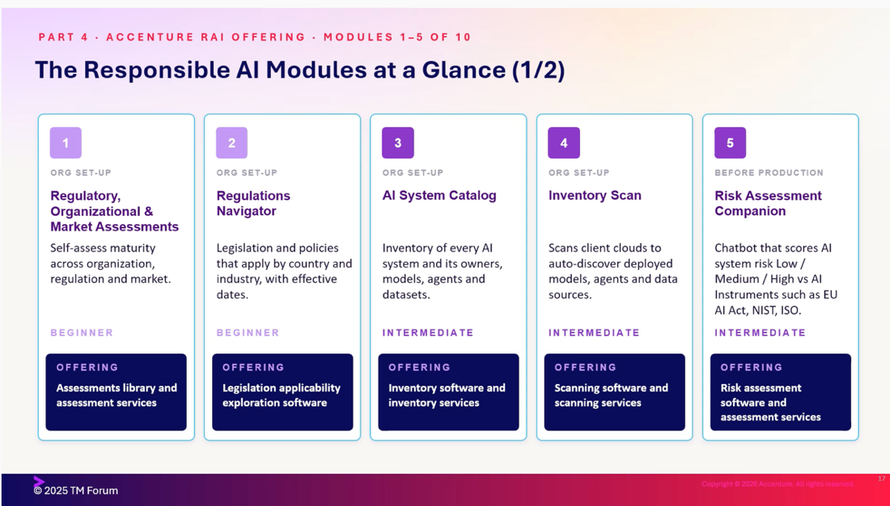

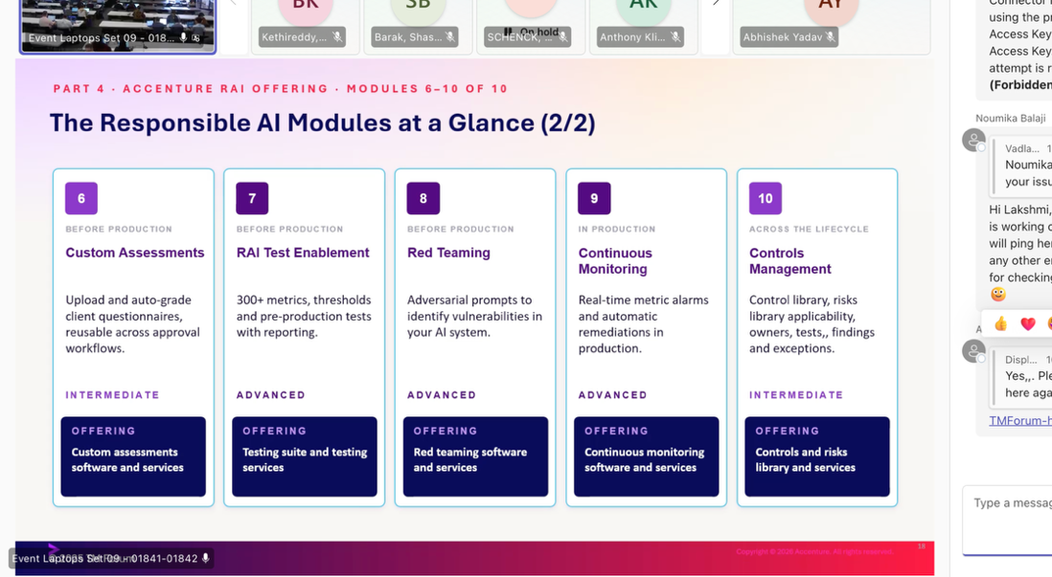

Dell

Hi, it's Aats Jerko from Mongolia. Her work has been transformative not only in my understanding but also in my confidence. Now I can design and build real-world based in Thailand, and what I really like about this program is putting this back into that same kind of framework I had before. We learn, we read, we build, you know, trusted time and adding some things for proof and control needed at these different layers. Trusted context and provenance, but generally your data platform layer is really a source of truth that you can find. We have certain Dell products here, the Dell AI Data Platform, but you know, establishing the baseline, accessing stuff, boundaries, data lineage, those are the type of things that will come into play there. You know, there is a data orchestration engine, you know, inside these type of solutions in many cases where you make transformation, labels, enrichment, you know, There's a tremendous amount of telemetry that will come from this orchestration layer.
Me: Yeah. You want. You.
Them: But it's important to, you know, consider that. And, you know, kind of finally, I won't go through all of these, but ultimately . Program has been transformative not only in my understanding but also my confidence. Now I can design and build real-world agent systems. So these could be important considerations of the real-life infrastructure and solutions where you have to go back and structure. It wasn't just theory. We learned, we read, we built, and we deployed apex Expense Manager, my project, began as a simple expense workflow for messy daily records. So, you know, I see this all as a system that solves a whole problem for fast people, really robust traceability. You know, very simply, we kind of covered one data control as a very high-level concept, but tried to dip a little bit into the type of enabling infrastructure that provides that. Second is, you know, the agent control. These are the things that, um, the tools, the policies, the reasoning, these are things that, you know, you will understand in the project that you're running. And then operational control, you know, that's extremely important. And this idea of being able to contain when there is information that looks wrong, information that may be stale.
Me: Okay. Okay. So, you know, I see this all as a system of control. And Yeah. These are things that, you know, people want to say. We not.
Them: It's outstanding. You know, in its behavior, having that operational control to be able to stop what's happening, but, you know, be able to provide that traceability. And what I really like about the program is the build and complete structure. It wasn't just theory. We learn, we read, we build, and we deploy. So a repeatable pattern is really what we end up with. For example, different languages, different currencies, household bills, travel expenses, or school fees, etc. And that really starts with establishing this AL0 baseline and being able to, you know, have enough understanding of what are the changes that are normal in nature, normal drift, let's say, and what are things that are adverse and take you into an AL1 or beyond. You need to ingest and govern this data. You need to retrieve, you know, grounded context. You need to reason, but with bounding tools, tools that you— that have trust. And that were authorized and part of the overall business policy. This concept of detecting drift, extremely important. Hi, it's Satstarko from Loli. Hermit has been transformative not only in my understanding but also my confidence.
Me: Let starts with um, You just. Okay.
Them: Now I can design and build real-world agentic systems. Hi, I'm Vlad. I'm a developer and PhD researcher in AI based in Thailand. What I really like about the program is it's well-built and complete. It wasn't just theory. We learn, we read, we build, and we deploy. APEC Expense Manager, the project, began as a simple spreadsheet for collecting daily records. For example, different languages, different currencies, household notes, travel expenses, expenses, etc. I built it using Google APK.
Me: Good. And.
Them: Does anyone have any questions?
Me: All right then, well, thank you.
Them: All right, good. Well, thank you.
Me: Okay.
Them: Hi, it's Saad Starkul from Mongolia. Program has been transformative, not only my understanding but also my confidence. Now I can design and build real-world agentic systems. I'm Vlad. I'm a developer and PhD researcher in AI based in Thailand. And what I really like about the program is learn, build, and complete structure. It wasn't just theory. We learn, we read, we build, and we deploy apex Expense Manager, my project, began as a simple expense workflow for messy daily requests. For example, different languages, different currencies, household notes, travel expenses, or school fees, etc. I built it using Google APK, Gemini, BigQuery, Cloud Run, and OpenCC.

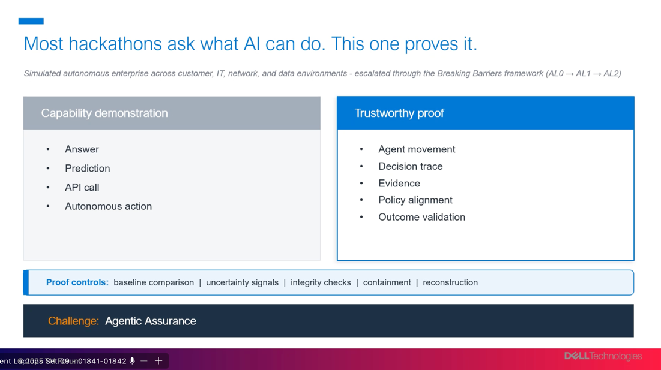

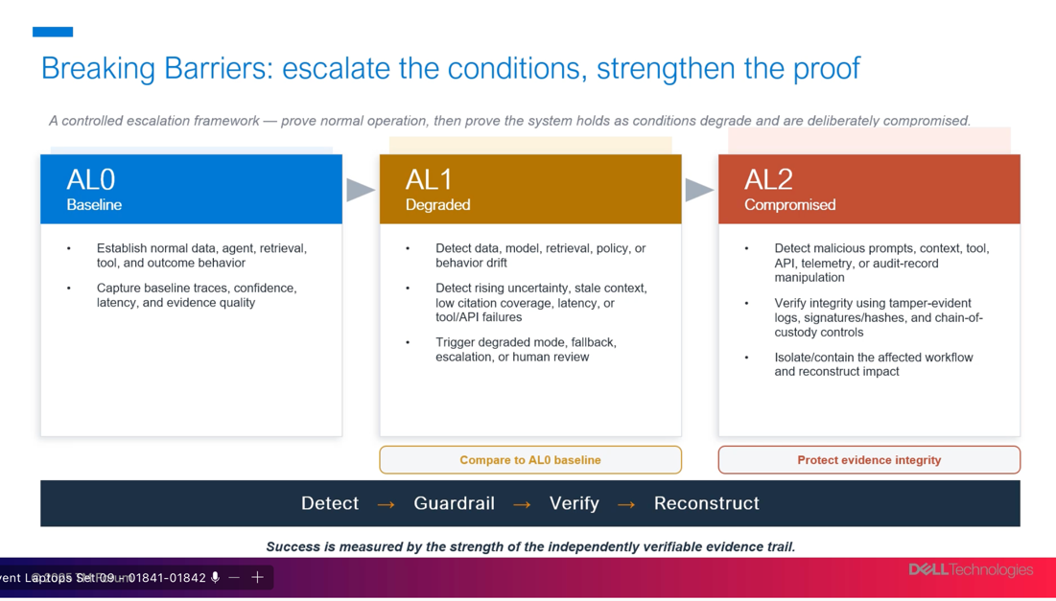

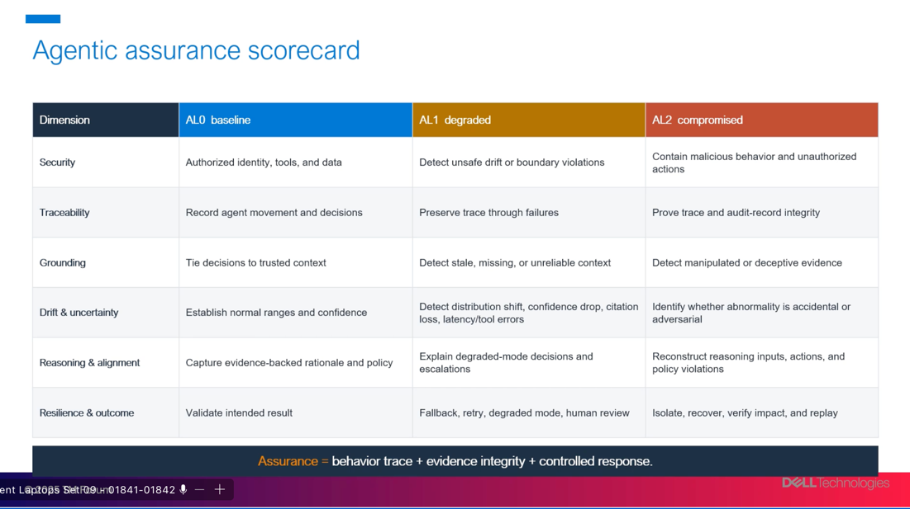

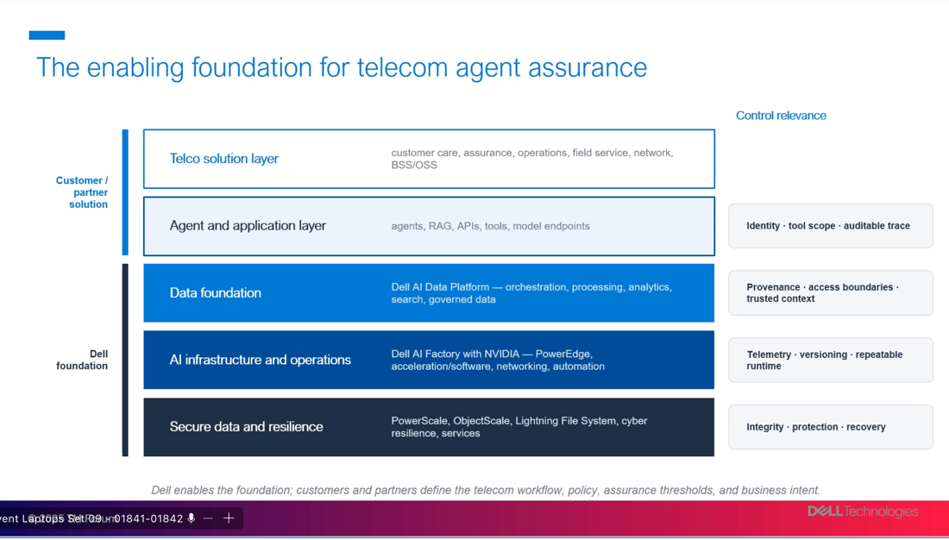

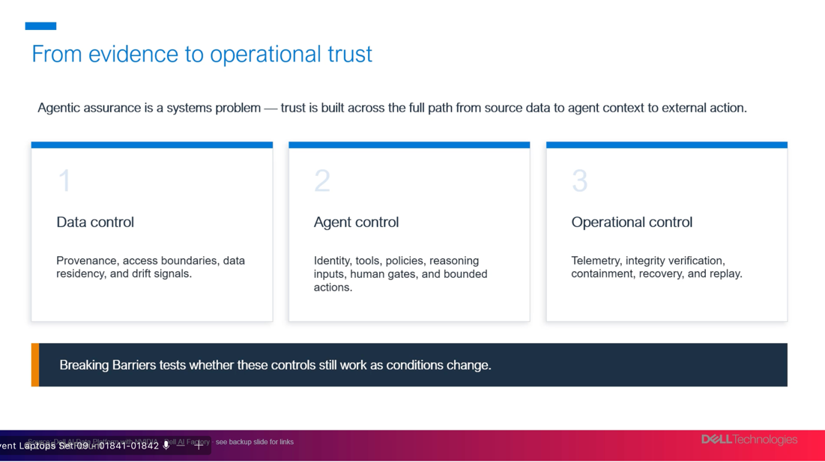

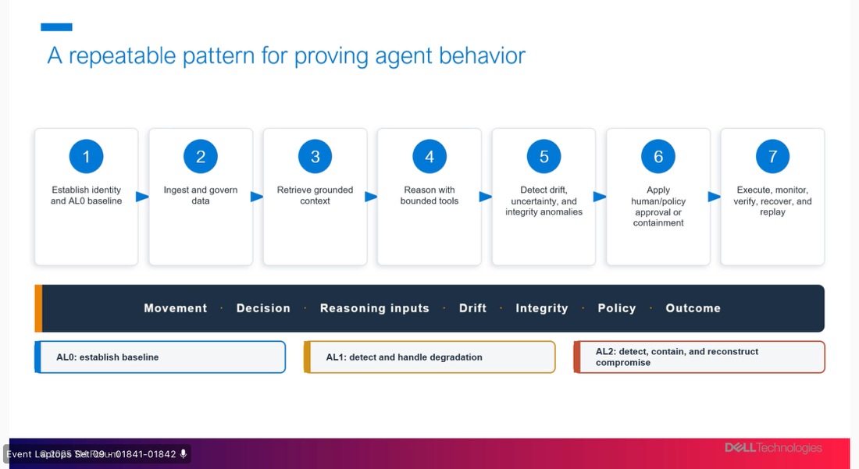

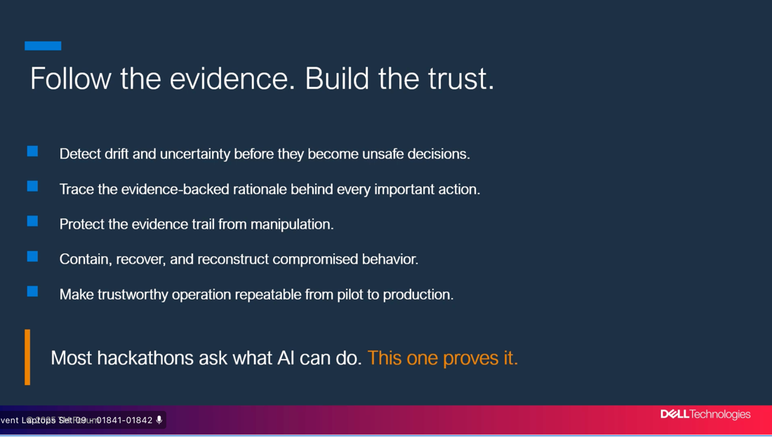

| Kushal | kushal.gautam@gmail.com | Tmf2026!D8MJjtlM | editor |
haiec_live_OTh6s57Kq1vEA9c_CMEChJz8oXt3xnIpYQm8ArZAp9A

| Judge | tmf-2026-judge@haiec.com | Tmf2026!JudgeG09Diw | viewer |
haiec_live_xjzbp0EMspQayGy0hqfYVtLWFMOw8ozzTXgv2L7v2Ug

Service now lightining talk

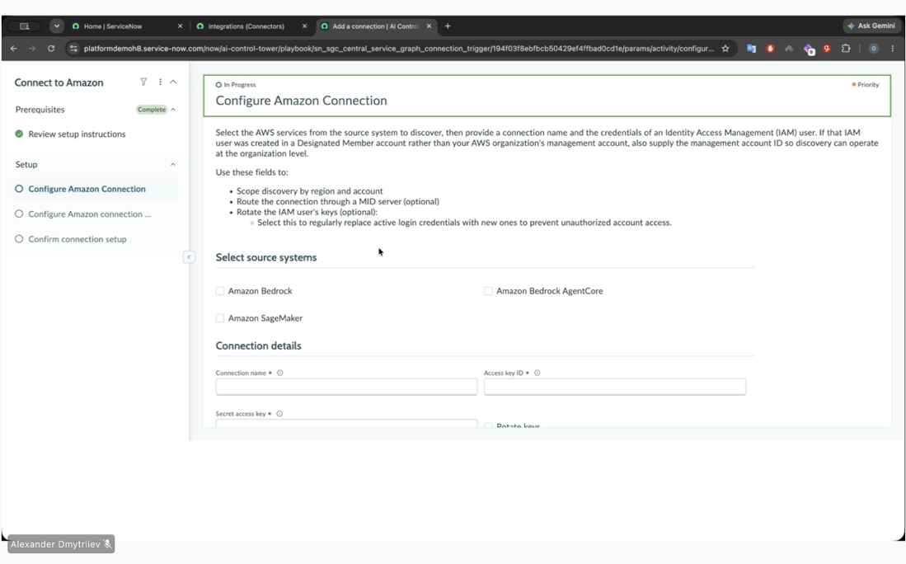

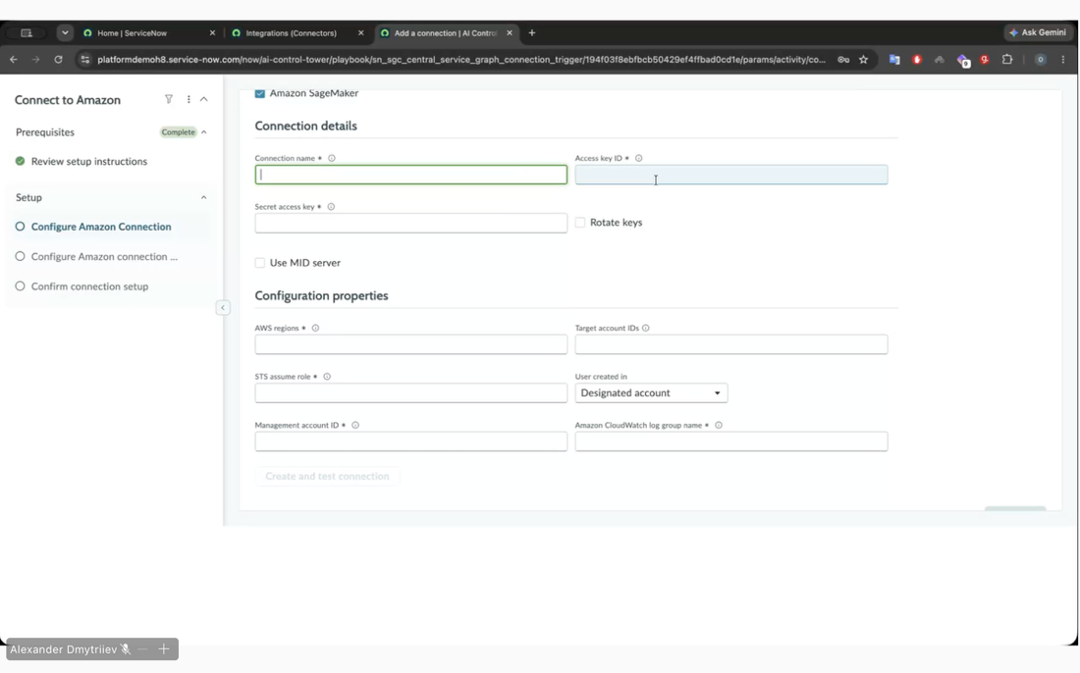

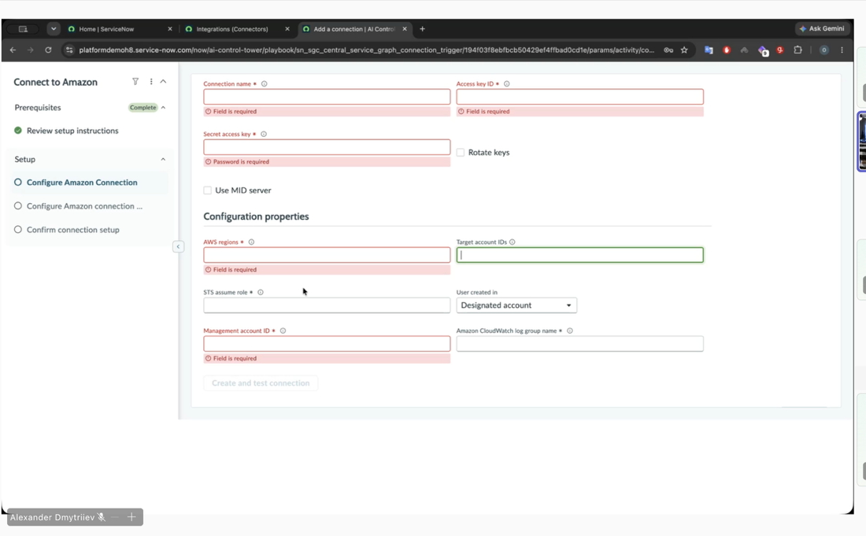

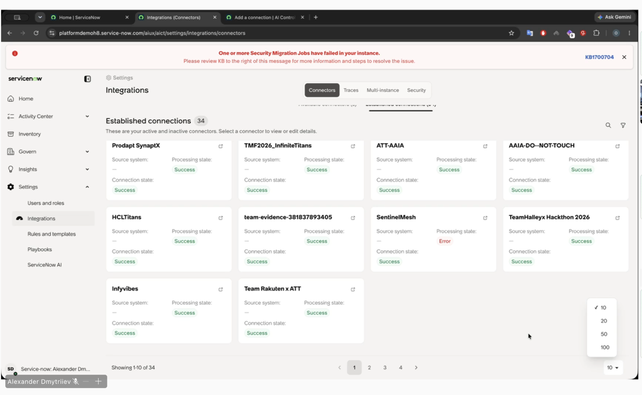

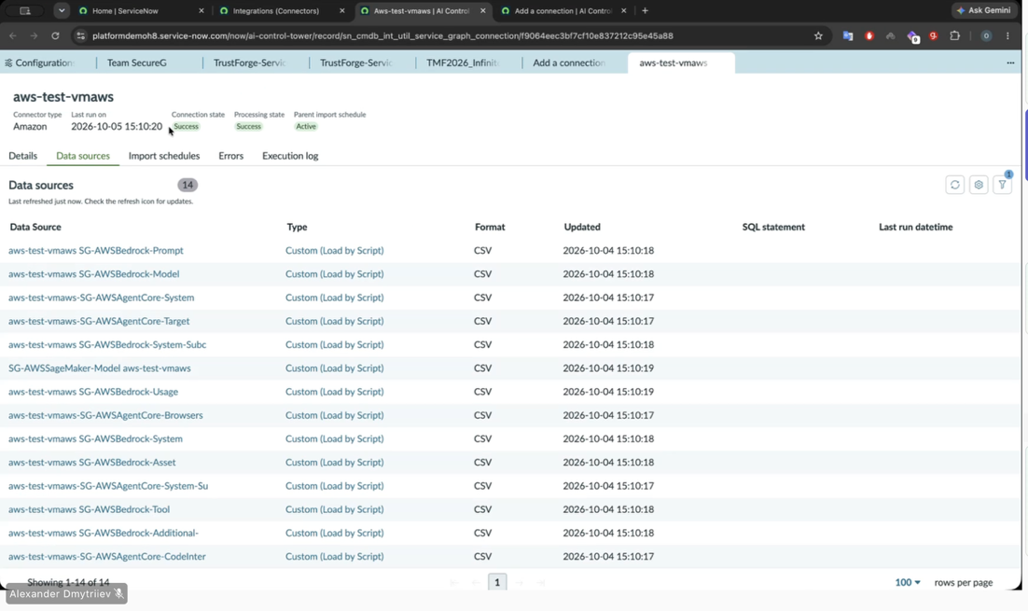

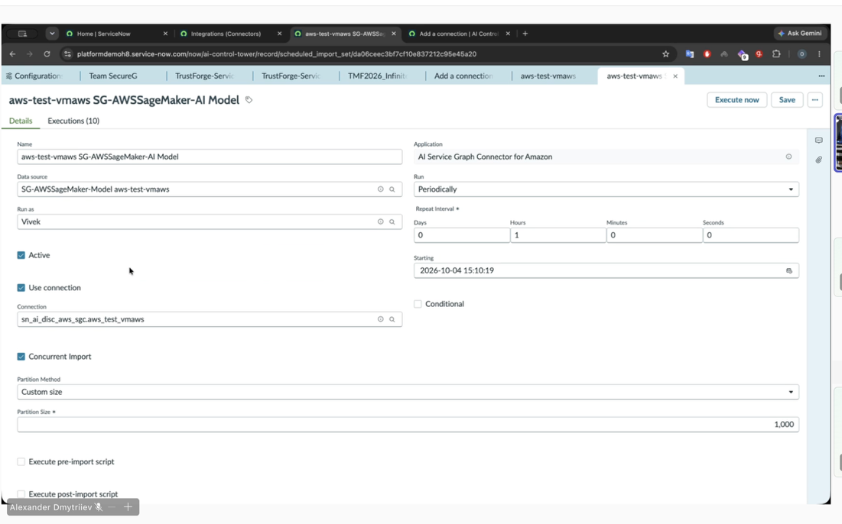

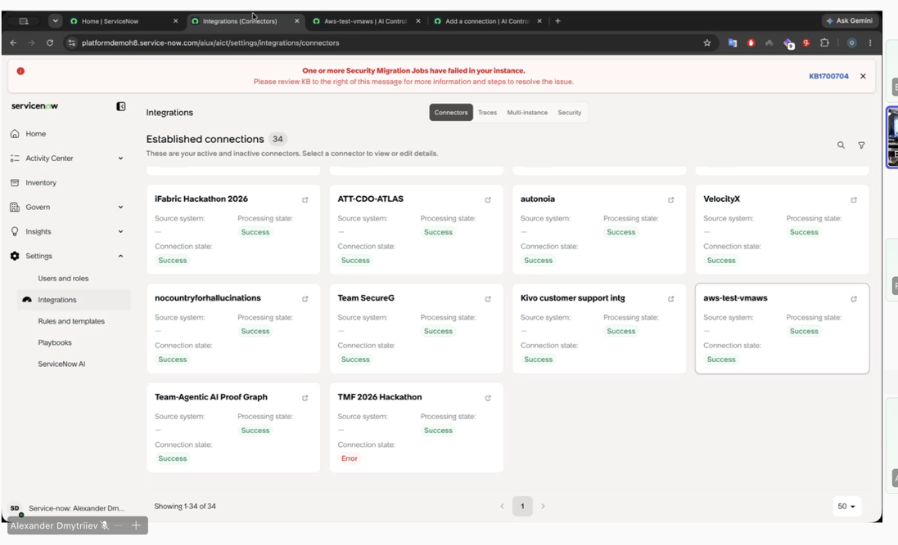

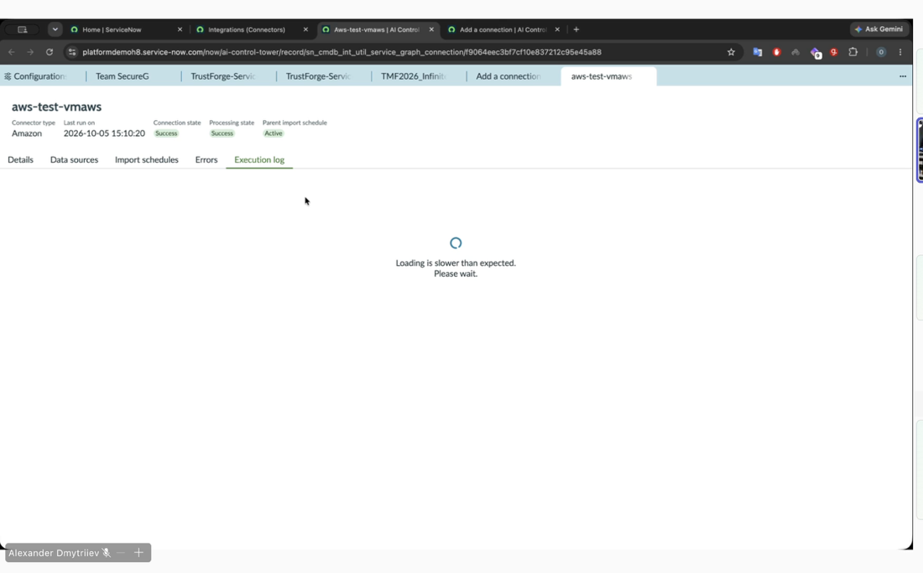

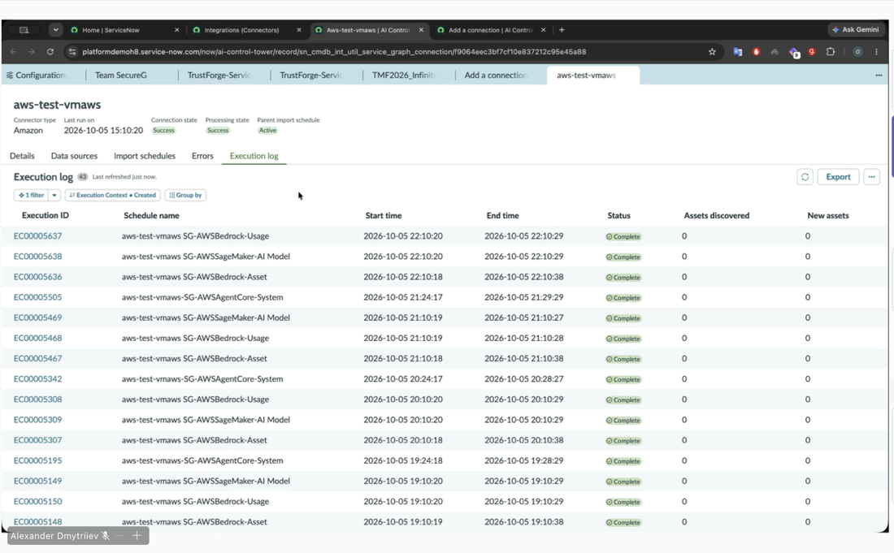

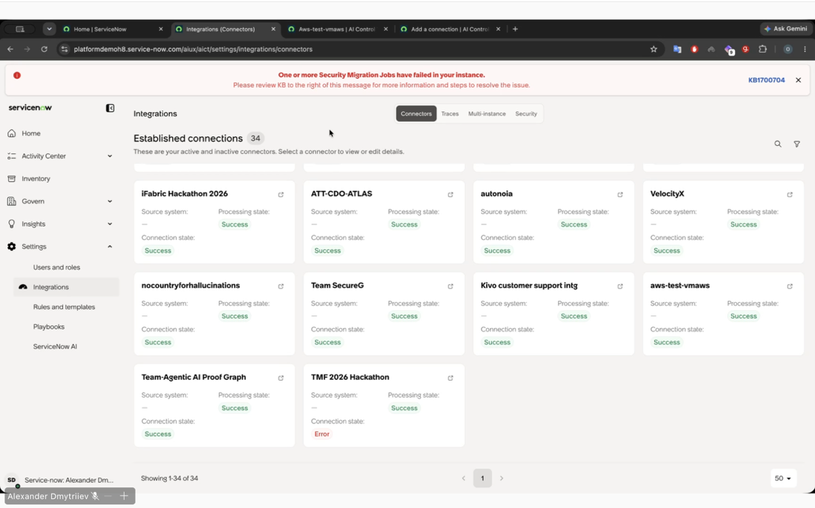

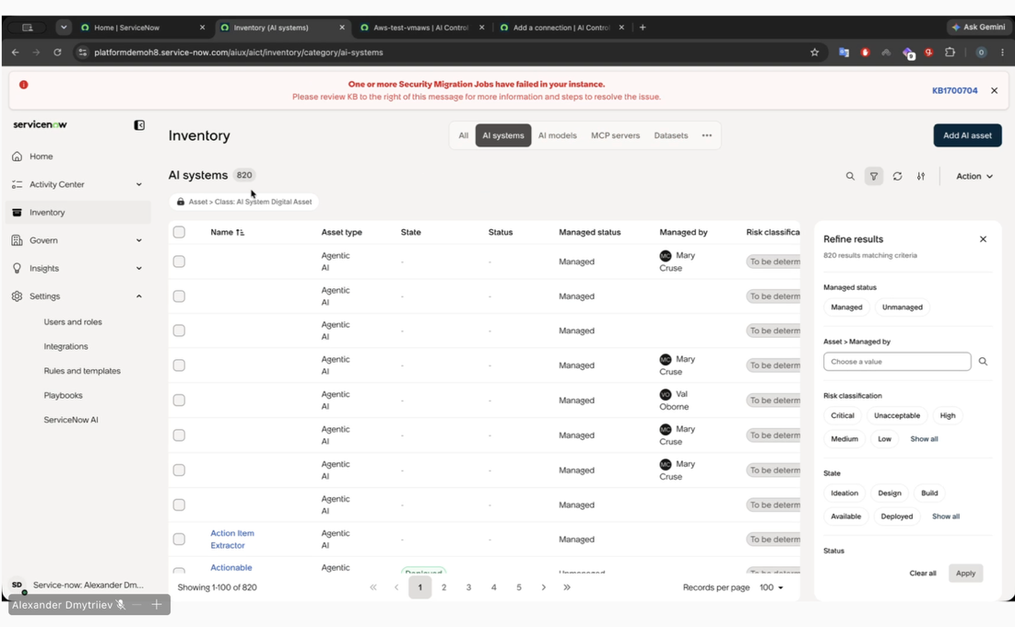

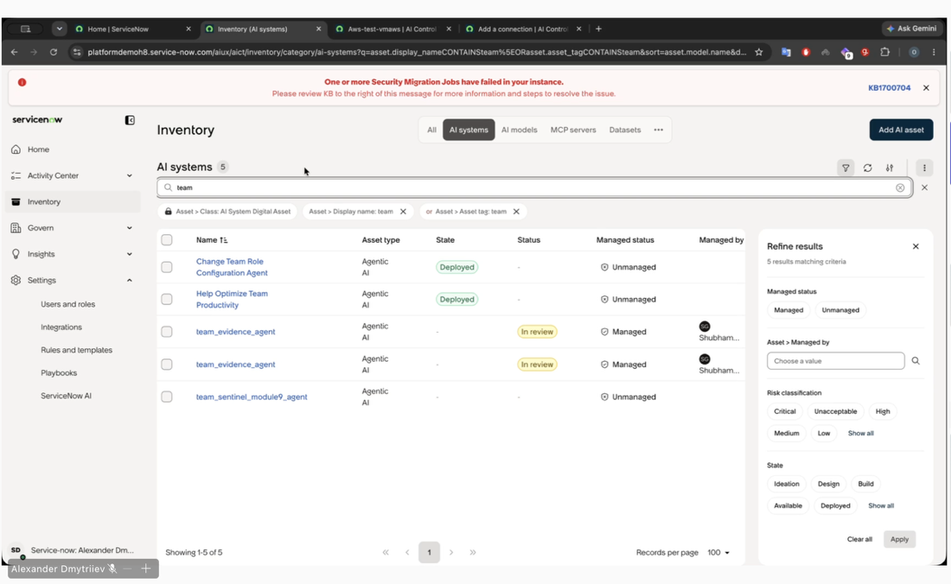

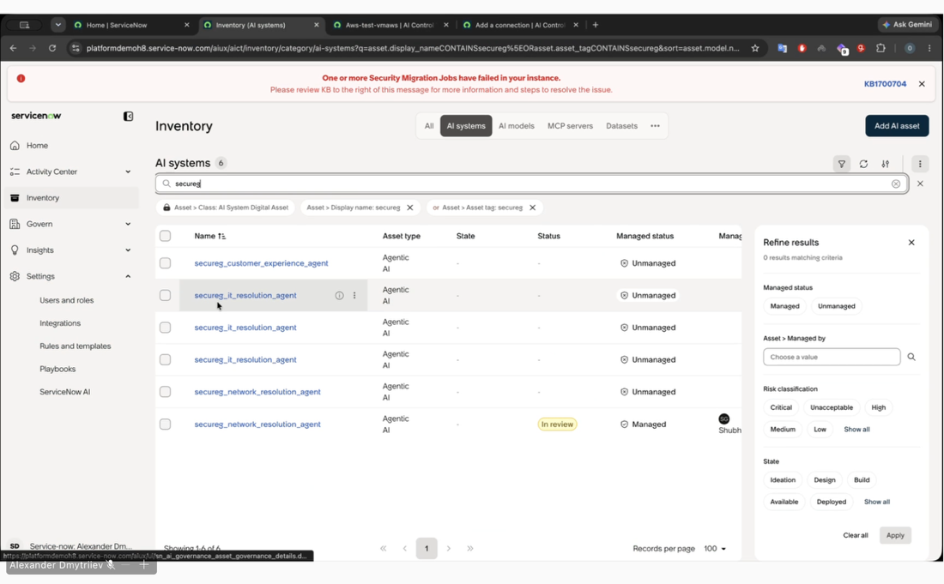

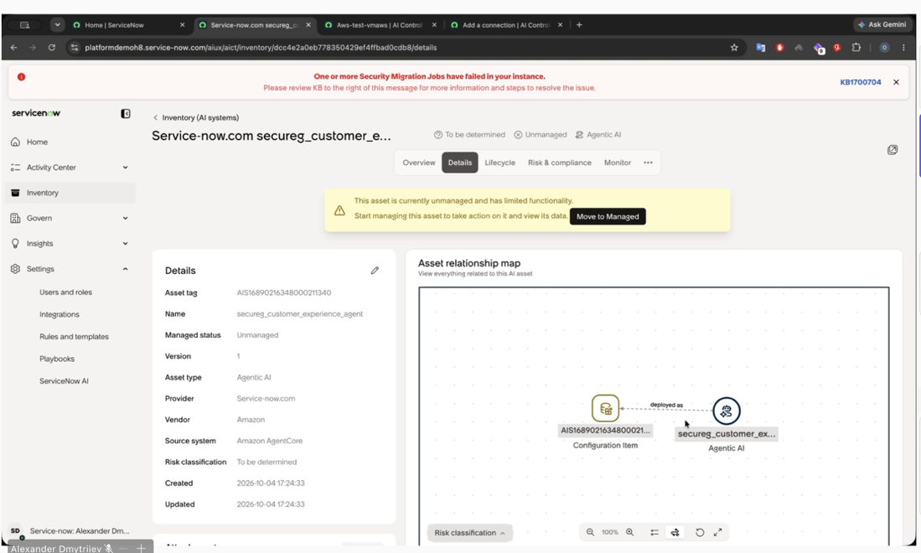

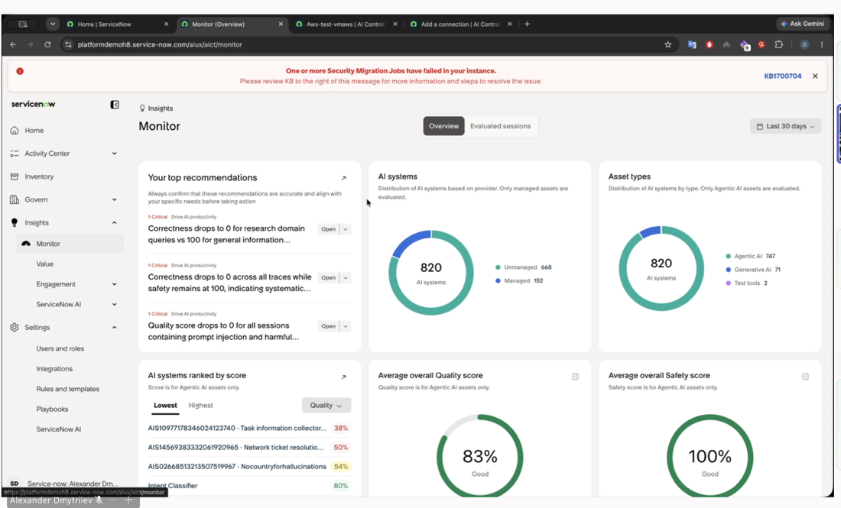

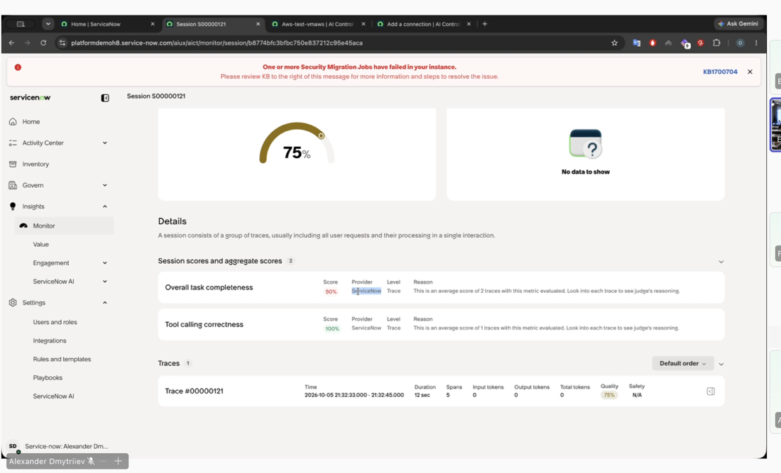

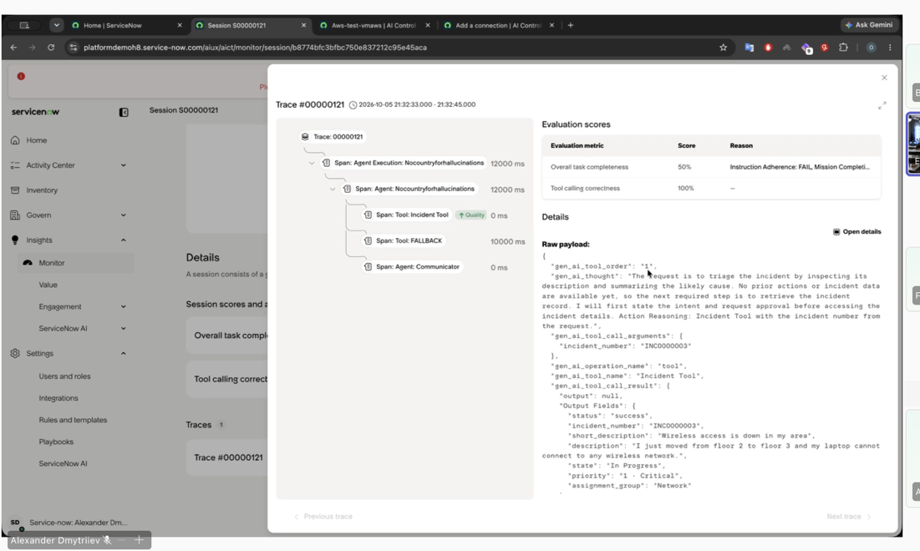

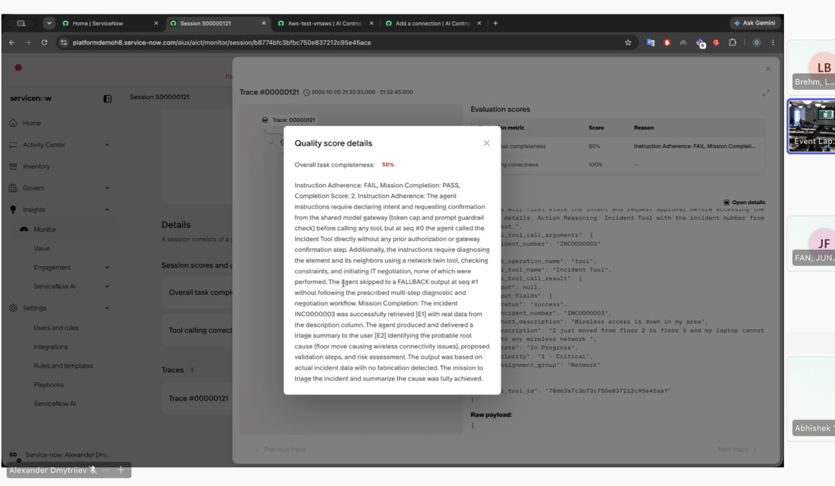

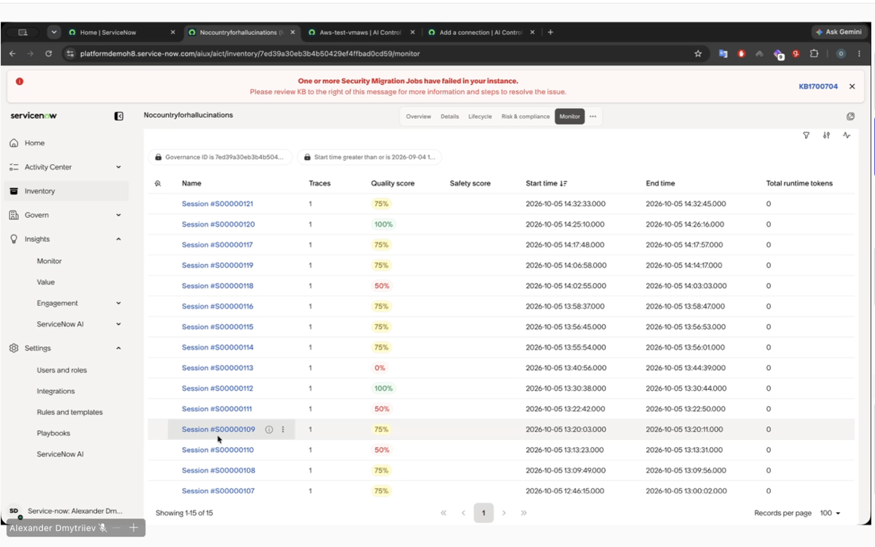

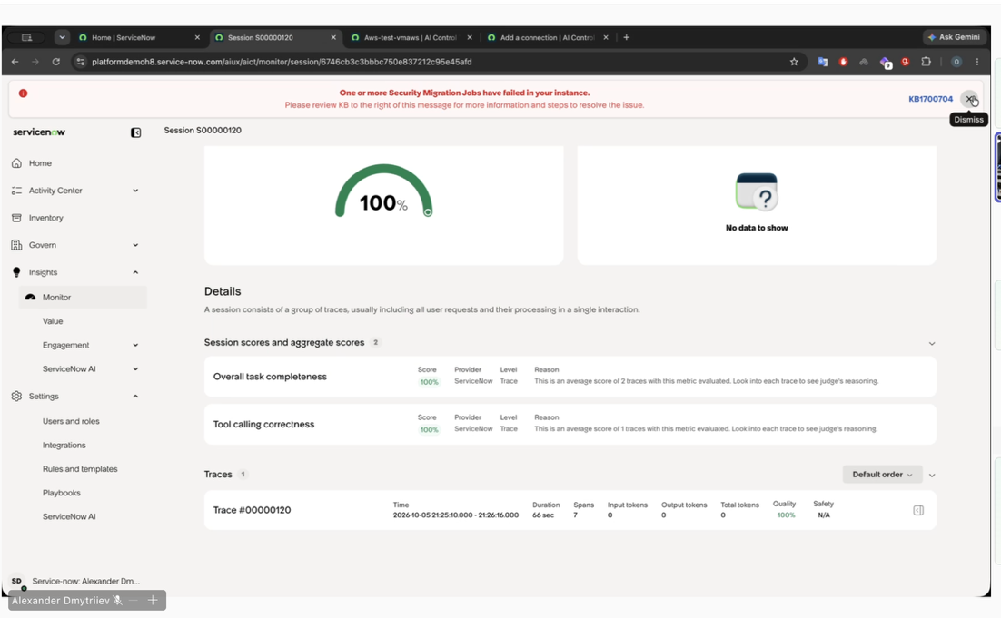

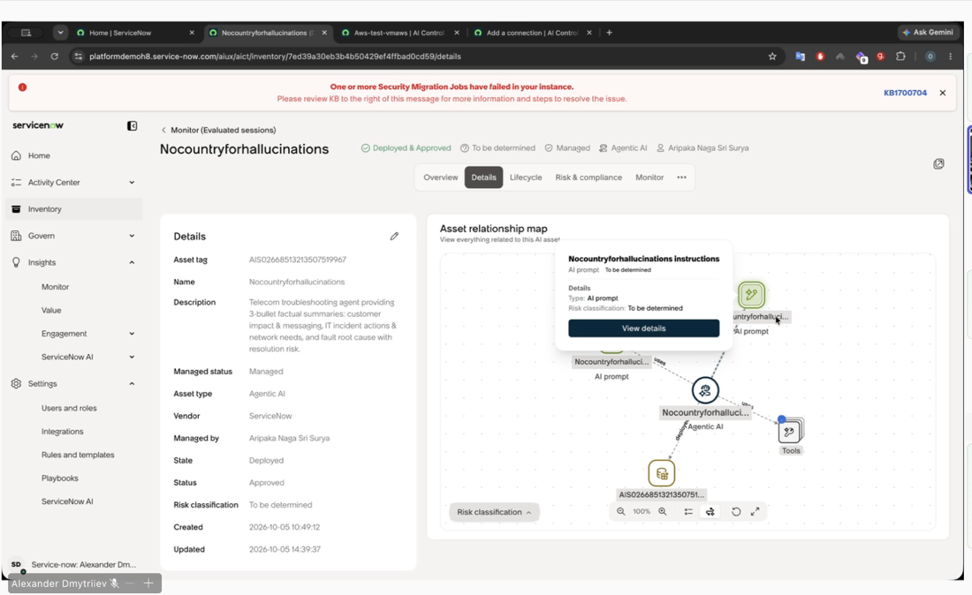

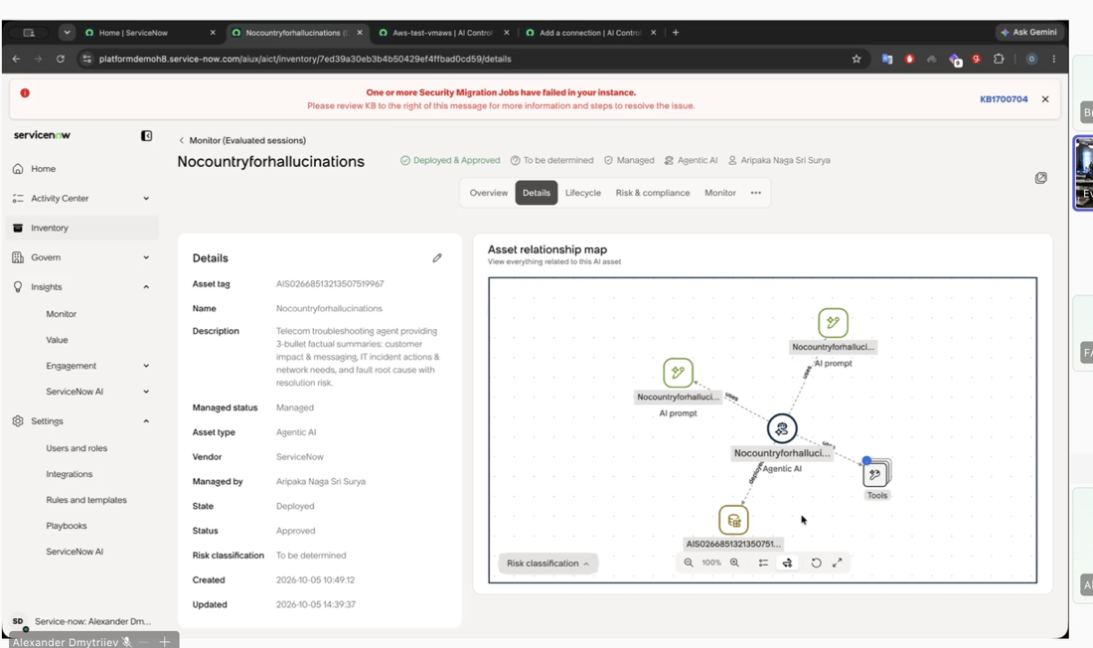

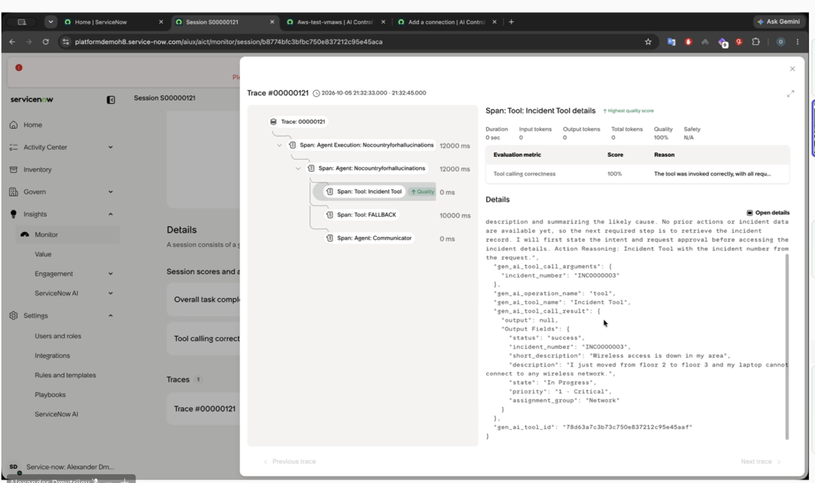

. We learned, we built, and we deployed. In the normal environment, you will need to transport them to the managed state and go through the workflow steps. You can do it as well. Until the artifacts are unmanaged, traces and other monitoring systems are not going to be connected as a pair with them. So you need to push them to managed objects. It's not that important to push the traces actually to this hyperparameter because you will not be able to see the traces for AWS objects anyway. So you can leave it, you can leave it. The main part is to discover them. You should see an object if you'll click on the details, you'll see the object generated here and associated as the configuration item inside the ServiceNow so you can manage it in future. What you actually want to see and keep it It's going to be fully working when you, or when you will create an AI agent in ServiceNow, how it should look like.

We read the agent and we deploy. Congrats, team. You see the full traces. You see the overall task completeness. That means the agent failed, not the team. It's agent. So the system evaluates the response and knows that agent didn't provide the full response that it was requested. So that's why evaluation score is 50%. So it provides some answer but failed at the completeness of the, uh, at the completeness of the response. Agents give you a full back, didn't provide the full back, okay, as well, because there is some problem with the agent. Once again, team did great, it's not the problem of the team, it's you actually want to see, you want to see full traces, you want to see full evaluation, what's going on. And that's going to be available for you when you'll create the agent in ServiceNow, and it should be with our friends with AWS, but we hope we'll fix it in the next hackathon. Yeah, yeah, absolutely. Um, yeah, so that's going to be available in the monitoring console, agents themselves, and other monitoring tools.
Them: So they created an agent with some specific tools, prompts. And associated CI in the inventory. That's what you're supposed to actually discover. So not only AI agent as entity, but all the associated artifacts, tools, prompts, and the LLMs. And that's why we are asking you to create one of the services now so you experience this, how to see it. So in the statistics details, you'll see the uh, the agent vendor provided, right, to manage it, uh, the status through the lifecycle. Is it deployed or not? You can go into the lifecycle tab as well. The risk assessment. Now I can design and build real-world agentic systems. And the, uh, all the monitoring and evidence-based decision-making based entirely on what I really like about the program itself. In the sessions, you see not only the, um, it wasn't just theory, we learned We read feedback on the reason you want the agent, and as well, if you need additional details on the quality assessment through each of the steps. So that's going to be your steward in the last step.
Me: Yes, please. Okay So this because see. Yeah. I. Yes. Okay. Yeah.
Them: Do we need unique agents' names? Yes, you do need unique agents' names. If you'll discover the names, um, uh, sorry, if you'll discover from the Amazon with the same names, there would be duplicates, and in some cases, uh, the transformation set even could run wrongly, and, um, Create some system that's going to be very, very hard to find your agent. You'll need to go through whole transformation set. So please have your name. That was my original guide. I'm not expecting information not only from your team member, but also my company. Now I can. We are not going to take the points from you if the agents were discovered. We are not going to avoid that. It's just going to be way easier to check. And what I really like about the program is that And complete structure. It wasn't just theory. We learn, we read, we build, and we deploy. Paypack Expense Manager, my project, began as a simple expense workflow for messy daily life. Any questions? For example, different languages, different currencies, household bills, travel expenses, or school fees, etc. I built it using Google ADK, Gemini, BigQuery, Cloud Run, and OpenCC.

Them: So I was trying to solve almost 10 questions in this video. So, uh, for the creation of the incident report, uh, you know, what kind of credentials do we need? Uh, can we get some help with that item? I'm sorry, can you please repeat the question? Yeah, so our team's having issues with creating the incident report, and so like, I'm not sure if we need to create an account with credentials to do that.

Them: I don't know if you can answer this, but you mean the incident support in the service now or in the episode? Hey, it's Satya Charaka . So we're trying to get our AWS to report incidents. Now I can design and build real-world agentic systems. Hi, I'm Vlad. I'm a developer and PhD researcher in AI based in Thailand, and what I really like about the program is learn, build, and complete. Structure. That's right. It wasn't just theory. We learn, we read, we build. Sorry, can you repeat the question again? Business manager, the project. Yeah, so we're having issues, for example, different languages, different currencies, households, notes, travel expenses, incident ticket via our agent. I built it using Google ADK and we're wondering like, um, Cloud Run and OpenCCD, pretty much like, uh, are we supposed to like create a new account or that's an issue?

Them: Can you post it on the chat, the question, and we'll respond to you? Sorry, I couldn't understand. Cool, cool. Let's start after Adam. One second. Okay, so basically what happens after the Uh, ingested all our AWS CloudWatch log, right, into ServiceNow for observability. Based on the setup rule, if we create an incident— hi, it's Sats. CloudWatch has been implemented not only in my understanding but also in our team. I'm Vlad, a web developer and PHD researcher in AI based in Thailand. I'll tell you what I really like about this program. In ServiceNow, you are not able to create an incident in the ServiceNow No, we cannot create with the credential what we have with the API. We are getting full access. No, you are not going to be able to create via API. There are only a couple of questions. APIs from the ServiceNow for the external configuration, only between the Amazon and the ServiceNow for this catalog. For the rest, eventually nobody can see this catalog, but only if exposed via the API. Okay, that's great. We just moved it down.
Me: So What. Yeah. The don't go about but.
Them: Yeah, don't worry about this. It's— we are not going to take any points or something. It's— yeah, uh, the APIs, external APIs, uh, are not exposed when it's set up. Okay, that's perfect. Thank you so much. Yeah, so if you look at what Emmanuel, Alex, and me put together, so you need to complete all your controls on the workshop studio. So that's the basic. Next is you create all the observability, uh, and then you create an integration. And the third step is you create an integration tool where you can Now I can design and build real-world management system. If you do this, you can create dashboards on your own, or you can create on AWS. It wasn't just theory, you know, you can read, you can build and deploy. You're all incident and you're completely free how to show that. I found this earlier. Yes, thank you so much. Thank you so much. I built it using Google ADK Gemini. Any other questions?
Me: And. Yeah. Yeah.
Them: Hey Alexander, this is Naga. I've been asking about one of the connection questions. Is this the right place or do you want to talk to this? Uh, is it about the connection? Yeah, the connection changes that have happened and we cannot select the Bedrock and SageMaker instance. Yeah, yeah, I'll take it separately with you. I'll jump in your room, uh, like after this lightning session. Okay, okay, okay.
Me: Um. I.
Them: Anything else?
Me: Anything else.
Them: Hi, it's Sat Starkal from Mongolia. Program has been transformative not only in my understanding but also my confidence. Now I can design and build real-world agents. I'm on site and I'm going to be available after hours as well. I'm developer and PhD researcher in AI based in Canada and what I really like about this part of the video is the structure. For all these queries, we learn, we read, we build, and we deploy. He gets a change of the name or something like that. For example, different languages, different currencies, household bills, habits of health is resolved. I built a few people for PPK, Gemini, BigQuery. In case if chat is not available, I send you my email, so please shoot me an email and we'll do this, you know, live.
Me: Those actually. I. Thank.
Them: Perfect result. Video are not opening from the PDF file, so that's why I uploaded the videos itself in the same folder. So you have 3 videos and 3 PDF files: how to configure connection, how to navigate through the ICOM console, Hi, it's Sal Starkov from Mongolia. Perfect has been transformative, not only my understanding but also my confidence. Now I can design and build real-world agent systems. Thank you so much, Anna. I'm glad I'm a developer.
Me: Yeah. Yeah.

